**Data inserting into the table:**

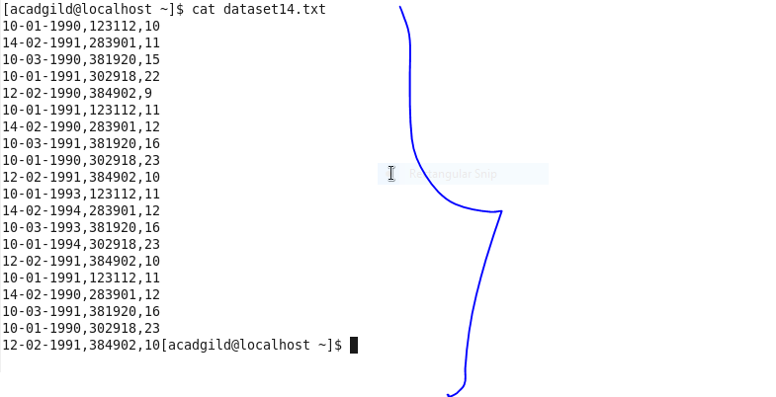

**Create database:**

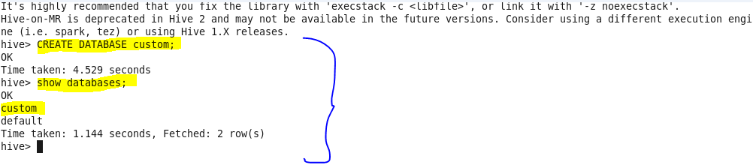

**Use database custom:**



**Create table temperature_data with comma delimited:**

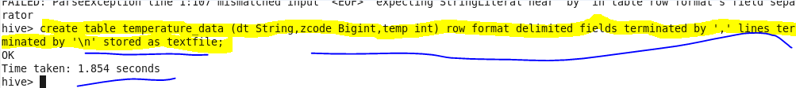

**Show table:**

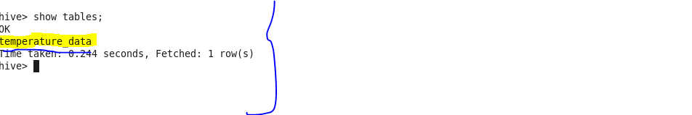

**Load the data into the table:**

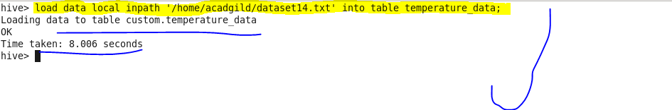

**Display the content of the table:**

